|  |  |  |  |  |  |  |  |  |  |
| --- | --- | --- | --- | --- | --- | --- | --- | --- | --- |
| **SCHOOL OF COMPUTER SCIENCE AND ARTIFICIAL INTELLIGENCE** | | | | | **DEPARTMENT OF COMPUTER SCIENCE ENGINEERING** | | | | |
| **ProgramName:**B. Tech | | | | **Assignment Type: Lab** | | | **AcademicYear:**2025-2026 | | |
| **CourseCoordinatorName** | | | | Venkataramana Veeramsetty | | | | | |
| **Instructor(s)Name** | | | | |  | | --- | | Dr. V. Venkataramana (Co-ordinator) | | Dr. T. Sampath Kumar | | Dr. Pramoda Patro | | Dr. Brij Kishor Tiwari | | Dr.J.Ravichander | | Dr. Mohammand Ali Shaik | | Dr. Anirodh Kumar | | Mr. S.Naresh Kumar | | Dr. RAJESH VELPULA | | Mr. Kundhan Kumar | | Ms. Ch.Rajitha | | Mr. M Prakash | | Mr. B.Raju | | Intern 1 (Dharma teja) | | Intern 2 (Sai Prasad) | | Intern 3 (Sowmya) | | NS_2 ( Mounika) | | | | | | |
| **CourseCode** | | | 24CS002PC215 | **CourseTitle** | | AI Assisted Coding | | | |
| **Year/Sem** | | | II/I | **Regulation** | | R24 | | | |
| **Date and Day**  **of Assignment** | | | Week2 - Wednesday | **Time(s)** | |  | | | |
| **Duration** | | | 2 Hours | **Applicableto**  **Batches** | |  | | | |
| **AssignmentNumber:4.3**(Present assignment number)/**24**(Total number of assignments) | | | | | | | | | |
|  | | | | | | | | | |
|  | **Q.No.** | **Question** | | | | | | ***ExpectedTime***  ***to complete*** |  |
|  | 1 | Lab 4: Advanced Prompt Engineering – Zero-shot, One-shot, and Few-shot Techniques  **Lab Objectives:**   * To explore and apply different levels of prompt examples in AI-assisted code generation. * To understand how zero-shot, one-shot, and few-shot prompting affect AI output quality. * To evaluate the impact of context richness and example quantity on AI performance. * To build awareness of prompt strategy effectiveness for different problem types.   **Lab Outcomes (LOs):**  After completing this lab, students will be able to:   * Use zero-shot prompting to instruct AI with minimal context. * Use one-shot prompting with a single example to guide AI code generation. * Apply few-shot prompting using multiple examples to improve AI responses. * Compare AI outputs across the three prompting strategies.   **Task Description#1**   * Zero-shot: Prompt AI to write a function that checks whether a given year is a leap year. * Write the python code about leap year in the simple logics ans functions   **Expected Output#1**   * AI-generated function with no examples provided   **Task Description#2**   * One-shot: Give one input-output example to guide AI in writing a function that converts centimeters to inches.   **Expected Output#2**   * Function with correct conversion logic   **Task Description#3**   * Few-shot: Provide 2–3 examples to generate a function that formats full names as “Last, First”. * Prompt: write the python code that generate a function that formats full name as last and first * Example 1: input : Enter your name :rakesh reddy * Output: rakesh is the first name * Reddy is the last name * Example 2: input : Enter your name last and first: varaprasad reddy * Output : varaprasad is the first name * Reddy is the last name   **Expected Output#3**   * Well-structured function respecting the examples   **Task Description#4**   * Compare zero-shot and few-shot prompts for writing a function that counts the number of vowels in a string. * **write a python function that takes inpput from the user and counts the number vowels are in a given string.** * **Eg1: Enter the string: Karra Rakesh.** * **Output:The number of vowels present in given string are : 4vowels(3a’s ,1e)** * **Eg2:Enter the string : Gundiga Akhil** * **Output:The number of vowels present in given string are : 5vowels(2a’s,1u,2i’s)**   **Expected Output#4**   * Functional output and comparative reflection   **Task Description#5**   * Use few-shot prompting to generate a function that reads a .txt file and returns the number of lines.   **Expected Output#5**   * Working file-processing function with AI-guided logic   **Note: Report should be submitted a word document for all tasks in a single document with prompts, comments & code explanation, and output and if required, screenshots**  **Evaluation Criteria:**   | **Criteria** | **Max Marks** | | --- | --- | | Zero Shot (Task #1) | 0.5 | | One Shot (Task#2) | 0.5 | | Few Shot (Task#3 & Task #5) | 1.0 | | Comparison (Task#4) | 0.5 | | **Total** | **2.5 Marks** | | | | | | | Week2 - Wednesday |  |

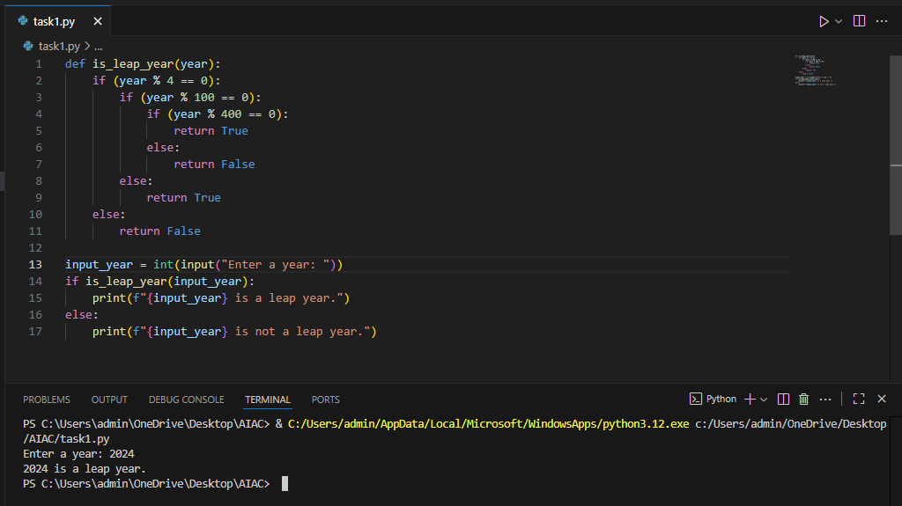

**Prompt:** write a python code to find whether the given year is a leap year or not

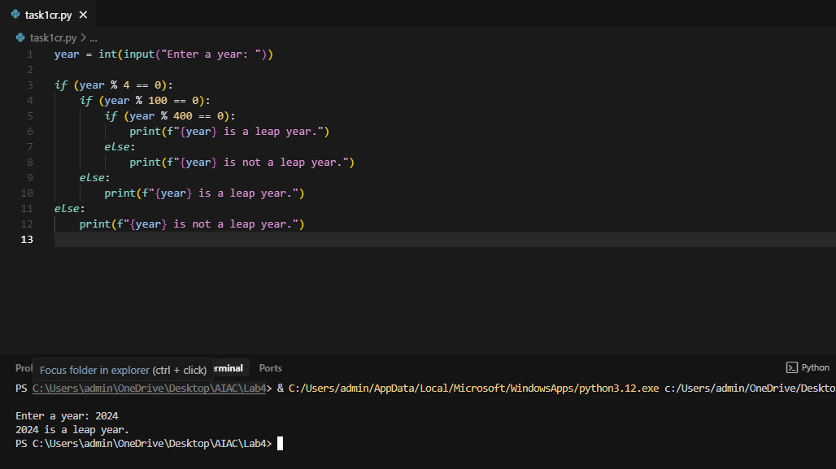

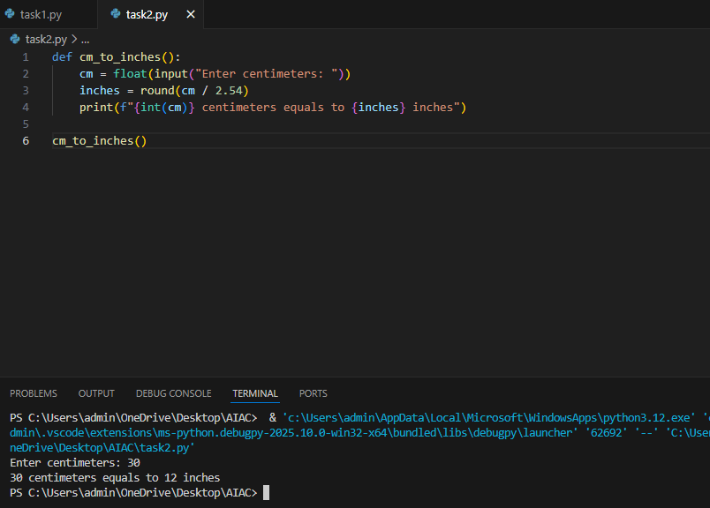

**Prompt:** write a python function that takes input from the user and converts centimeters into inches.(example.. input : 5.8 // output: 2 inches)

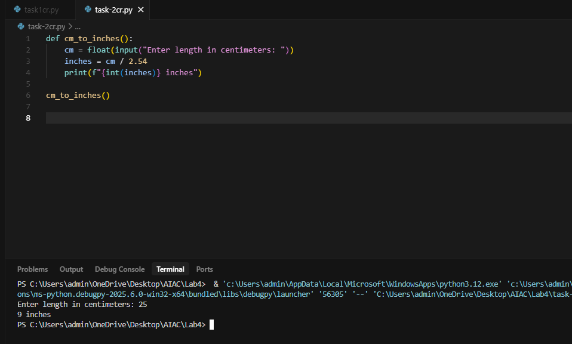

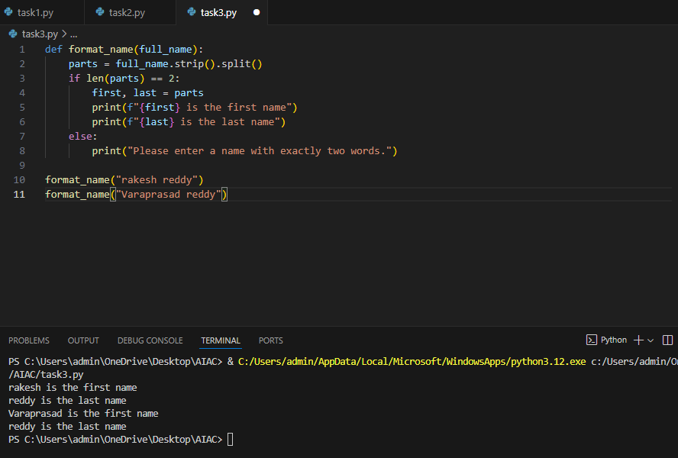

* **Prompt:**  write the python code that generate a function that formats full name as last and first
* Example 1: input : Enter your name :rakesh reddy
* Output: rakesh is the first name
* Reddy is the last name
* Example 2: input : Enter your name last and first: varaprasad reddy
* Output : varaprasad is the first name
* Reddy is the last name

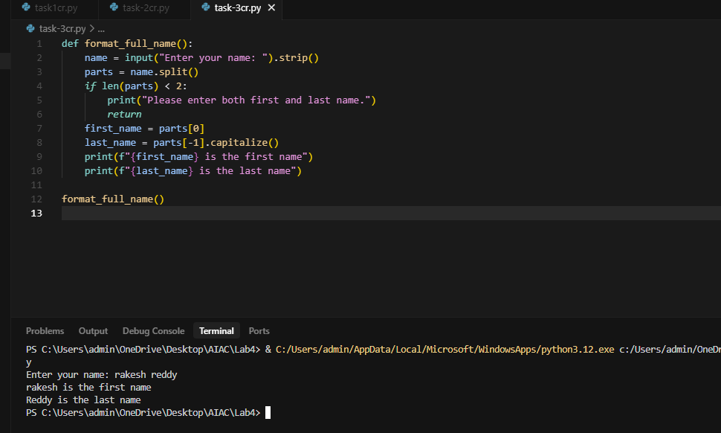

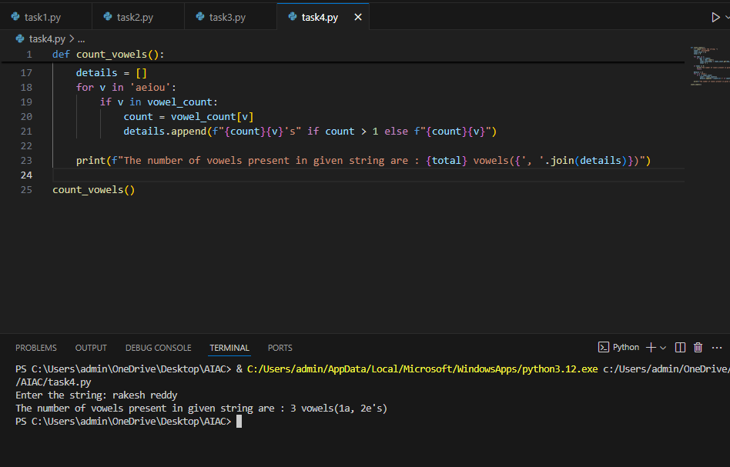

* **Prompt:** write a python function that takes inpput from the user and counts the number vowels are in a given string.
* Eg1: Enter the string: Karra Rakesh.
* Output:The number of vowels present in given string are : 4vowels(3a’s ,1e)
* Eg2:Enter the string : Gundiga Akhil
* Output:The number of vowels present in given string are : 5vowels(2a’s,1u,2i’s)

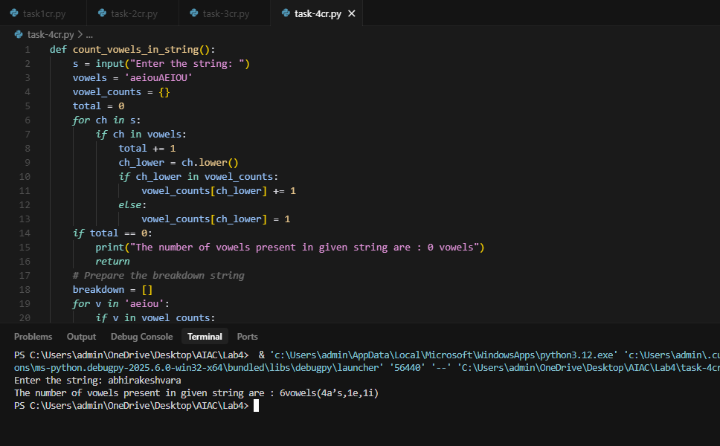

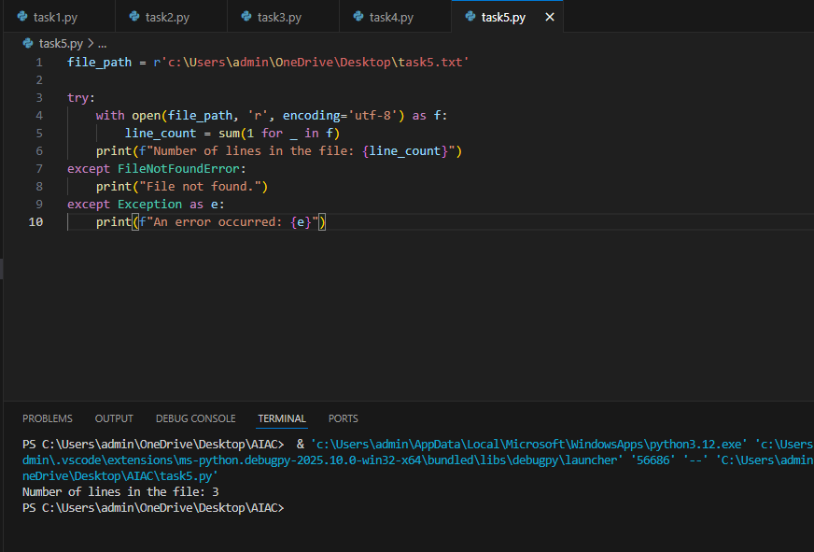

**Prompt:** Write a python program to read the no of lines present in " "C:\Users\savin\OneDrive\Desktop\AI.1.txt"" file and display the result on to the screen.

Example 1:

# Input: sample1.txt (contains 3 lines)

Output: 3

# Example 2:

# Input: sample2.txt (contains 5 lines)

     # Output: 5

